COMPUTER SYSTEMS VALIDATION EVIDENCE DOSSIER
Companion Screenshot Evidence & 21 CFR Part 11 Audit Trail
Protocol Document: | CLIN-EU-PAT-OPV-1-1-PQ-022
Protocol Version: | 1.0
Execution Timestamp: | 21-Oct-2026 (UTC)
Executed By: | sirihari.banda (CSV Automation Engine)
Compliance Standard: | 21 CFR Part 11 / EU Annex 11 Validated

Step TS1-S01: Accessing into Clinevo OnePV Intake Production Environment.
Status: Pass | Observed: Login page displayed successfully.
Procedure: Open Browser.
Enter the Production URL
URL: https://prod.one-aipv.com/login
Click on the Enter (Keyboard operation).
(Refer expected result)
(((µ)))...
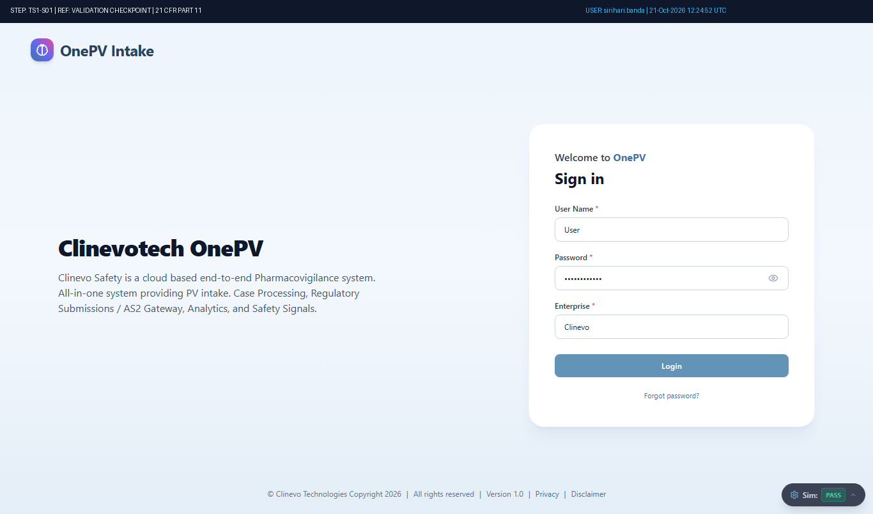
Figure: Audit-Stamped Evidence for TS1-S01 (Ref: TMP-CASE-6802)

Step TS1-S02: Login to Clinevo OnePV system
Status: Pass | Observed: Logged in as sirihari.banda. Header username and timestamp verified.
Procedure: Enter the following details in Login Page
User Name:
(Enter user name in text field)
Password:
(Enter the password)
Note: Enter the valid password for the user account at the runtime. User entered password at the runtime will be masked for securit...
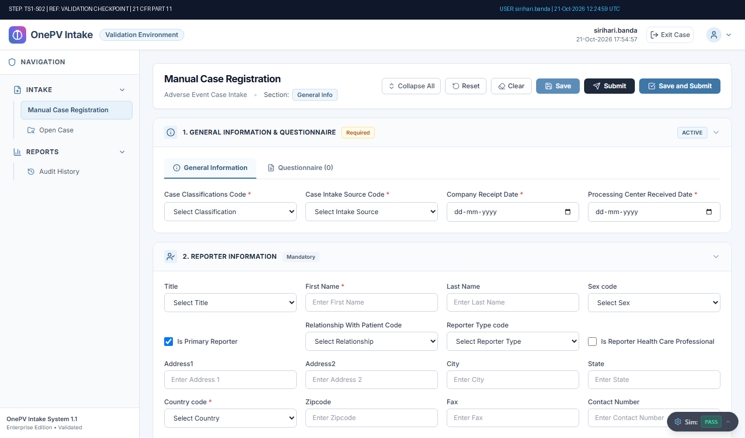
Figure: Audit-Stamped Evidence for TS1-S02 (Ref: TMP-CASE-6802)

Step TS1-S03: System shall allow to navigate Manual Case Registration page.
Status: Pass | Observed: Manual Case Registration form displayed with General Information and Intake sections.
Procedure: From left menu under Intake, Click on Manual Case Registration.
(Refer expected result)
(((µ)))...
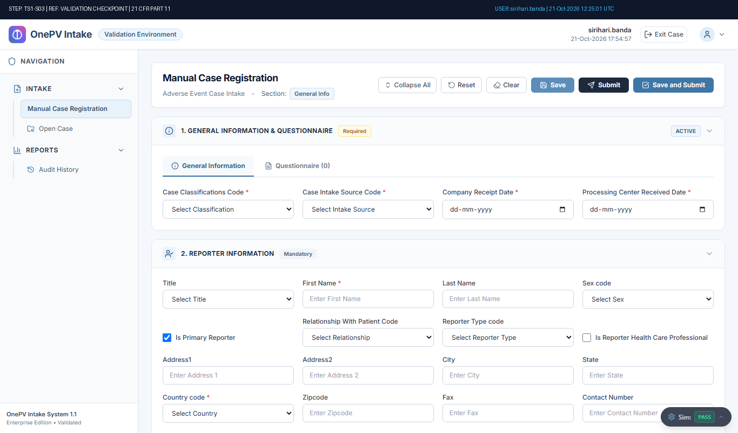
Figure: Audit-Stamped Evidence for TS1-S03 (Ref: TMP-CASE-6802)

Step TS1-S04: System shall allow to Register Case.
Status: Pass | Observed: Verified: System registered case successfully. Case ID TMP-CASE-6802 generated.
Procedure: In Manual Case Registry Page, under general info section enter the data in below fields,
Case Classifications Code: Adverse Event
(Select case classification from dropdown)
Case Intake Source Code:
(Select from the dropdown)
Company Re...
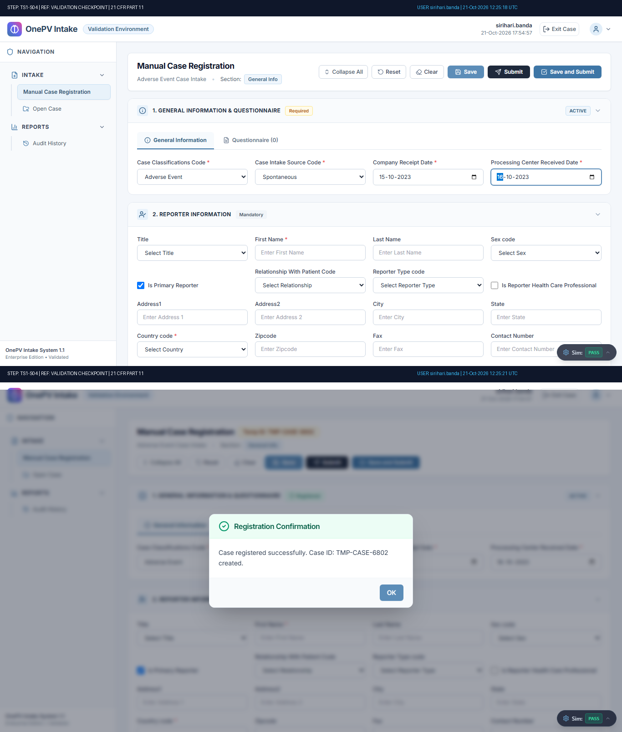
Figure: Audit-Stamped Evidence for TS1-S04 (Ref: TMP-CASE-6802)

Step TS1-S05: System shall allow to add Questionnaire manually.
Status: Pass | Observed: Question added manually with confirmation message and displayed under Questionnaire tab.
Procedure: Under General Info, from Questionnaire tab click on add questions button.
(Refer expected result 1)
In Additional Question message, click on Add Questions Manually radio button and enter data in below fields,
Field Type:
(Select from the dropdown)...
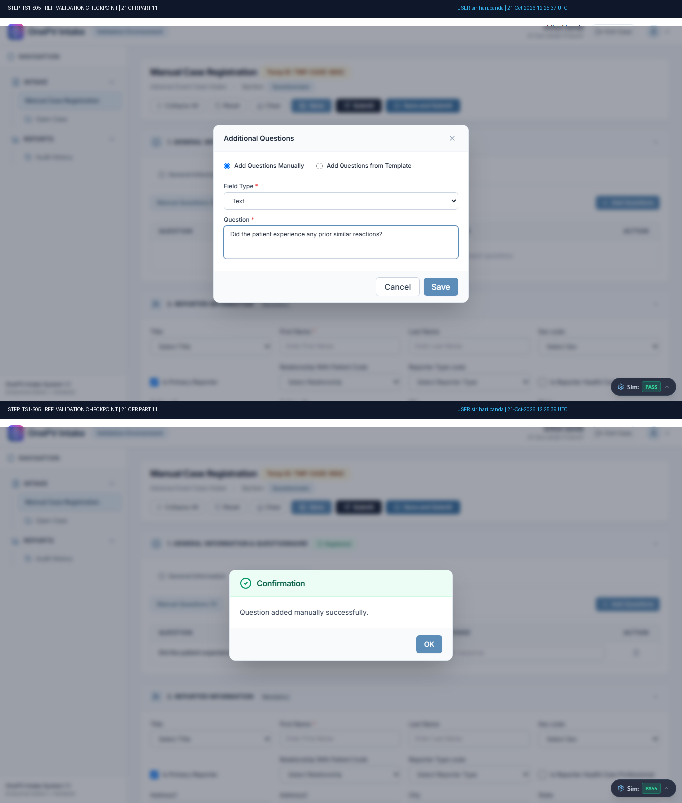
Figure: Audit-Stamped Evidence for TS1-S05 (Ref: TMP-CASE-6802)

Step TS1-S06: System shall allow to provide response for manually created question.
Status: Pass | Observed: Questionnaire response entered and saved successfully with confirmation message.
Procedure: Under response column, enter the response for the added questions.
Under Questionnaire tab, click on the Save button.
(Refer expected result)
(((µ)))
Click on OK button from the confirmation message....
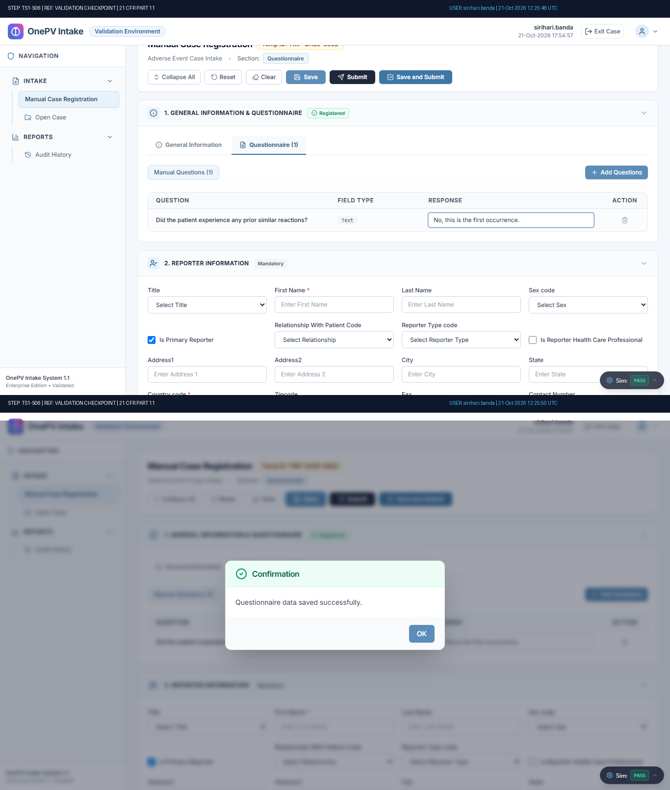
Figure: Audit-Stamped Evidence for TS1-S06 (Ref: TMP-CASE-6802)

Step TS1-S07: System shall allow to add Questionnaire from template.
Status: Pass | Observed: FAQ Template dialog selected and displayed.
Procedure: Under General Info, from Questionnaire tab click on add questions button.
In the Additional Question message, click on Add Questions from Template radio button and select template.
Click on Select button.
(Refer expected result)
(((µ)))
Click on OK...
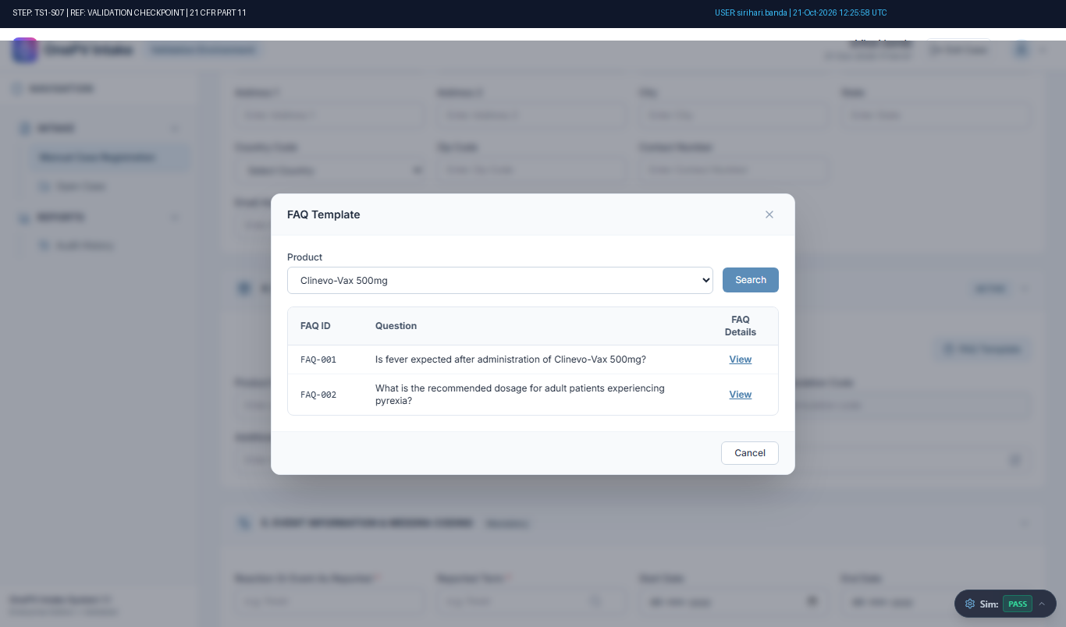
Figure: Audit-Stamped Evidence for TS1-S07 (Ref: TMP-CASE-6802)

Step TS1-S08: System shall allow to provide response for created question from template under Questionnaire tab.
Status: Pass | Observed: Template questionnaire response saved successfully.
Procedure: Under Questionnaire section, click on imported template tab.
Under response column, Enter the data for the provided question.
Under Questionnaire tab, click on the Save button.
(Refer expected result)
(((µ)))
Click on OK button from confirmation me...
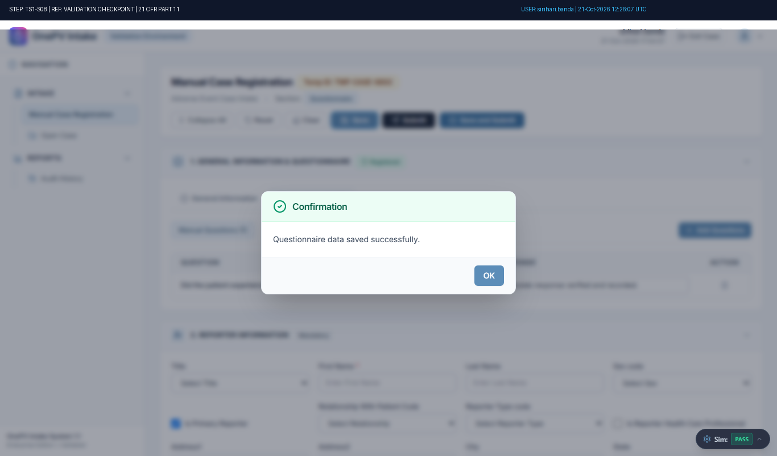
Figure: Audit-Stamped Evidence for TS1-S08 (Ref: TMP-CASE-6802)

Step TS1-S09: System shall allow to add reporter.
Status: Pass | Observed: Reporter information (16/16 fields) saved successfully with confirmation message.
Procedure: Under Reporter section, enter data in below details:
Title:
(Choose the value from dropdown)
First Name:
(enter the data)
Last Name:
(enter the data)
Sex code:
(Select from dropdown)
Relationship With Patient Code:
(Select from dropdown)
Re...
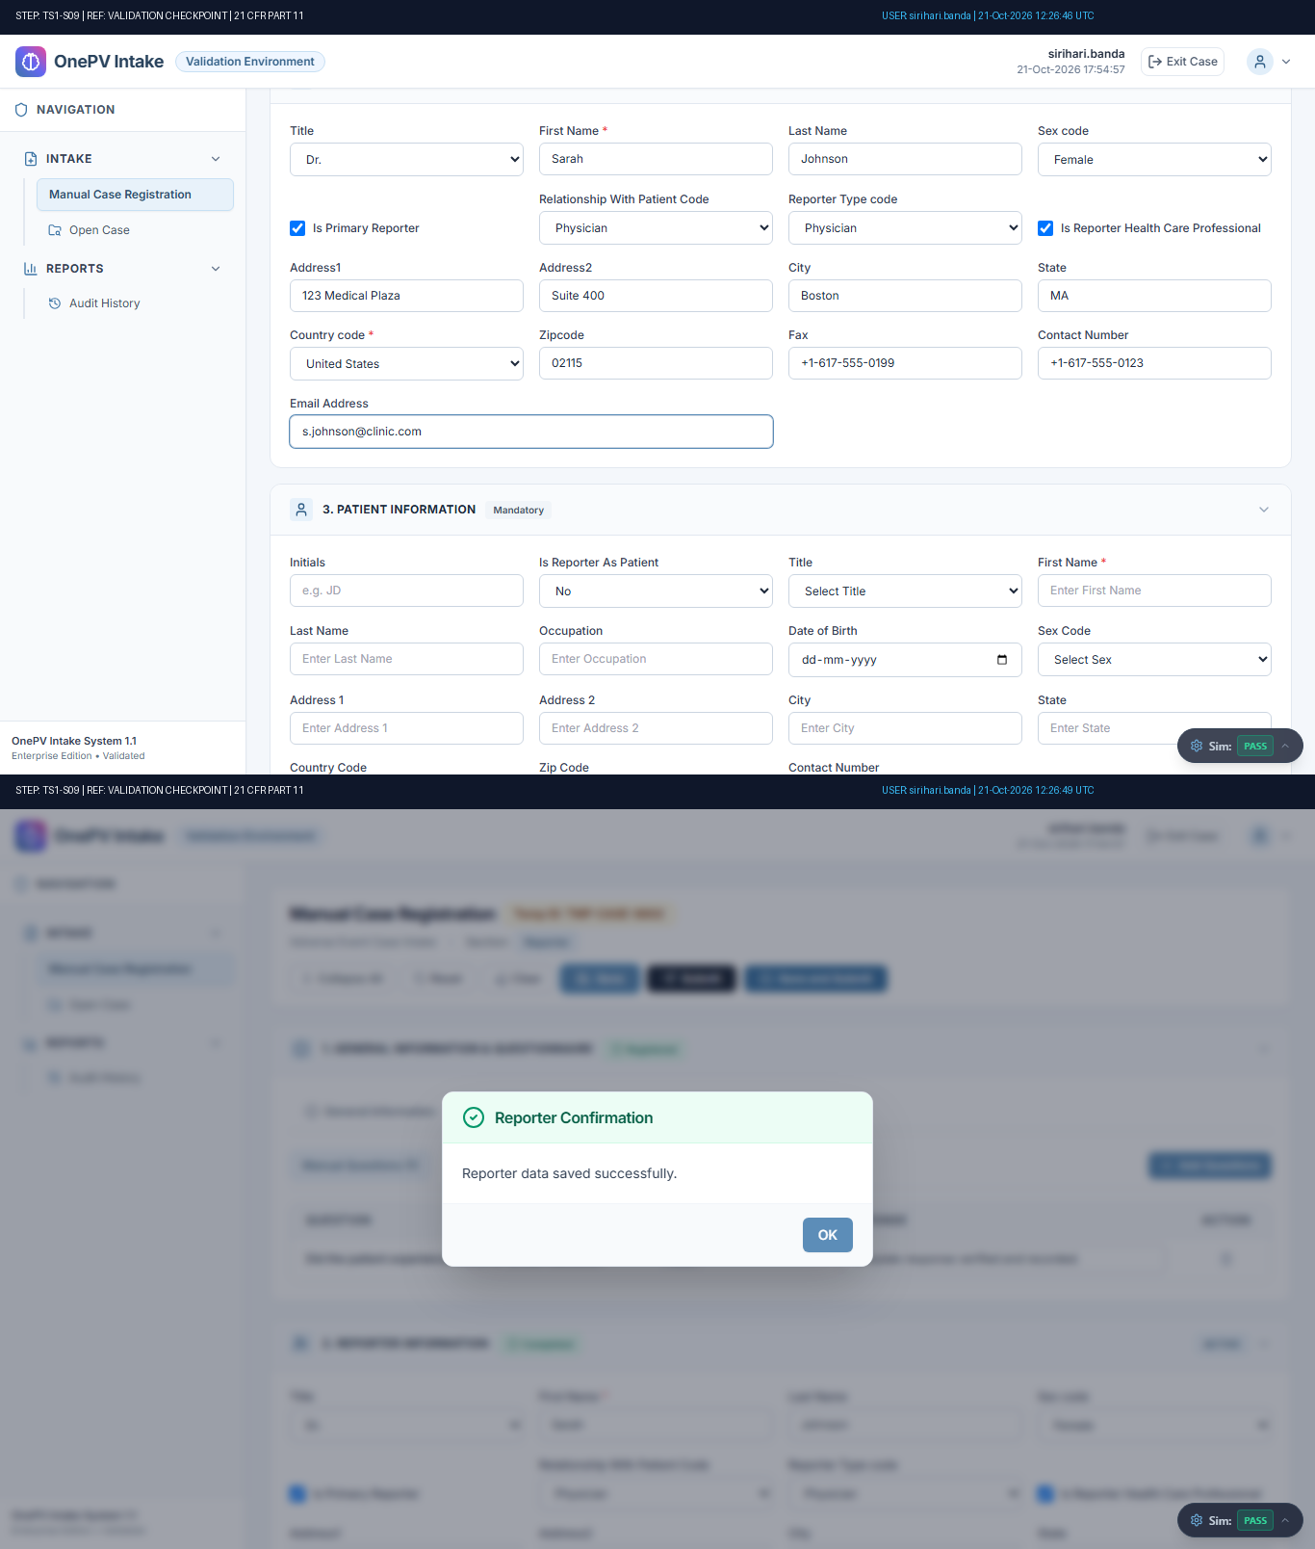
Figure: Audit-Stamped Evidence for TS1-S09 (Ref: TMP-CASE-6802)

Step TS1-S10: System shall allow to Add Patient information.
Status: Pass | Observed: Patient information (15/15 fields) saved successfully with confirmation message.
Procedure: Under Patient Information section, enter the data in below details:
Initials:
(Enter the data)
Is Reporter As Patient: No
(Select from the dropdown)
Title:
(Select from dropdown)
First Name:
(Enter the data)
Last Name:
...
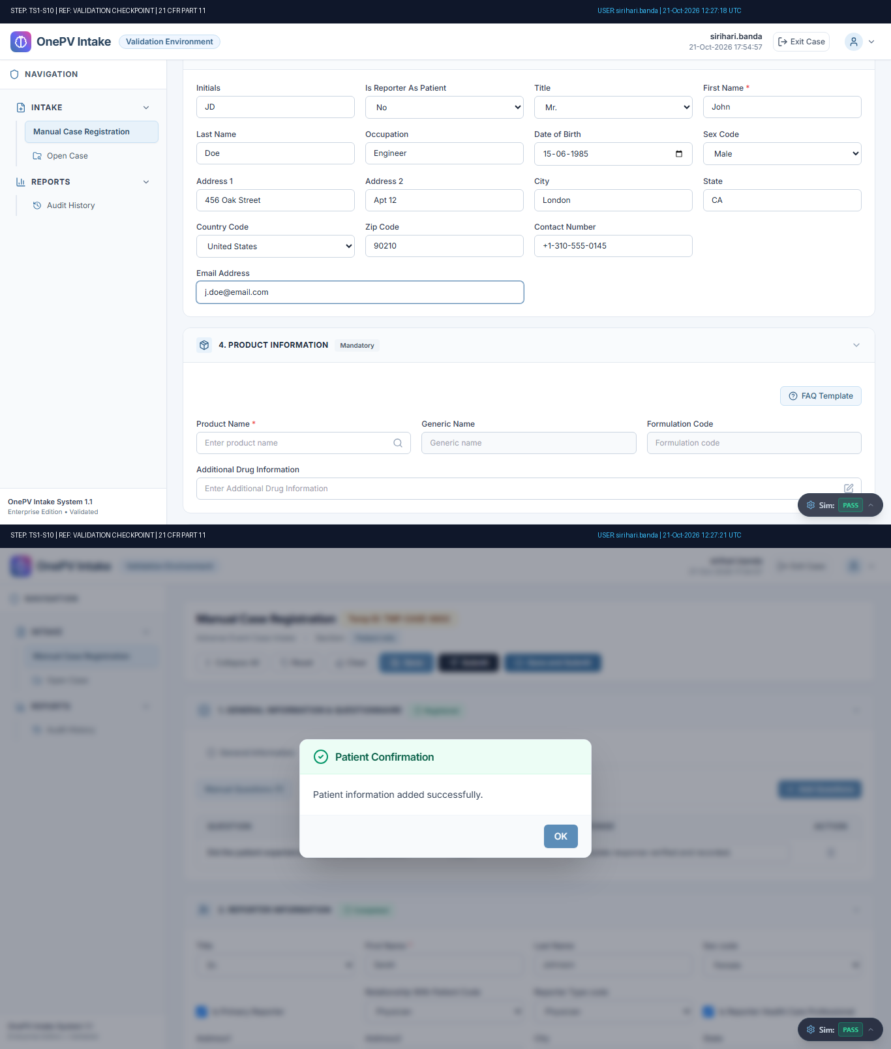
Figure: Audit-Stamped Evidence for TS1-S10 (Ref: TMP-CASE-6802)

Step TS1-S11: System shall allow to Add product.
Status: Pass | Observed: Product information added. Generic: 'Paracetamol', Formulation: 'TAB - Film-Coated Tablet' auto-populated.
Procedure: Under Product Information section, enter the data in below fields,
Product Name:
(Click the Search icon, enter the product name in the search field, and click the Search button. Select the required product using the radio button, and click the Selec...
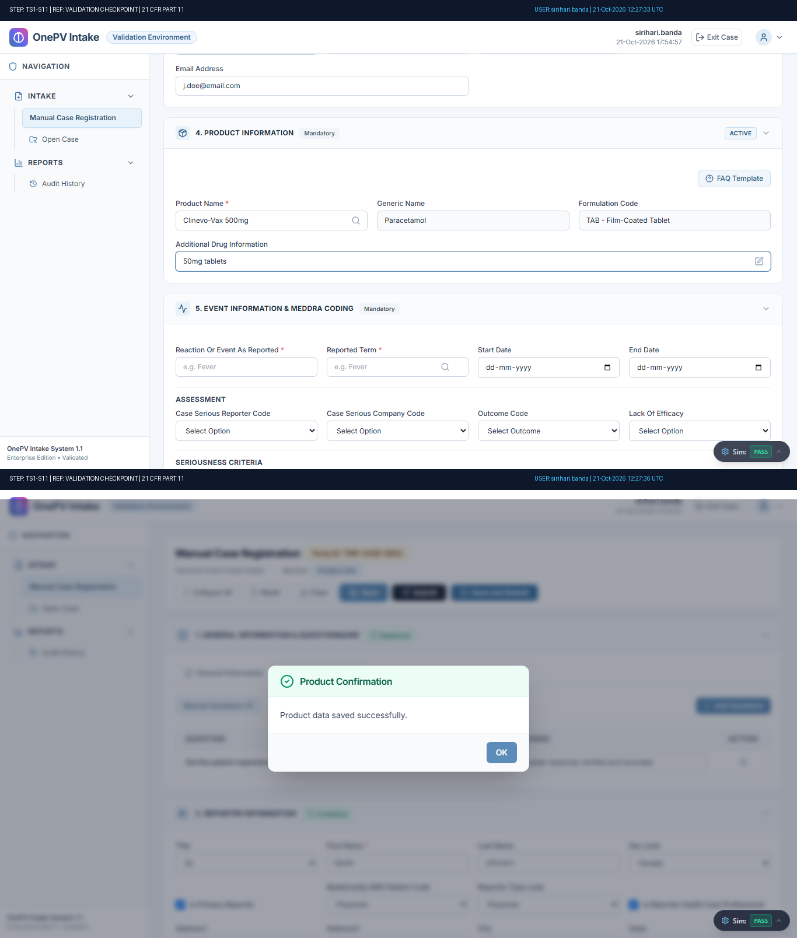
Figure: Audit-Stamped Evidence for TS1-S11 (Ref: TMP-CASE-6802)

Step TS1-S12: System shall allow to Add Event Information.
Status: Pass | Observed: MedDRA code 10019211 displayed and Event saved (4 assessment & 8 seriousness dropdowns verified).
Procedure: Under Event Information section, enter the data in below fields,
Reaction Or Event As Reported:
(Enter the data in the text field)
Reported Term:
(Enter term and click on the reported term search icon and select the meddra code)
(Refer expected r...
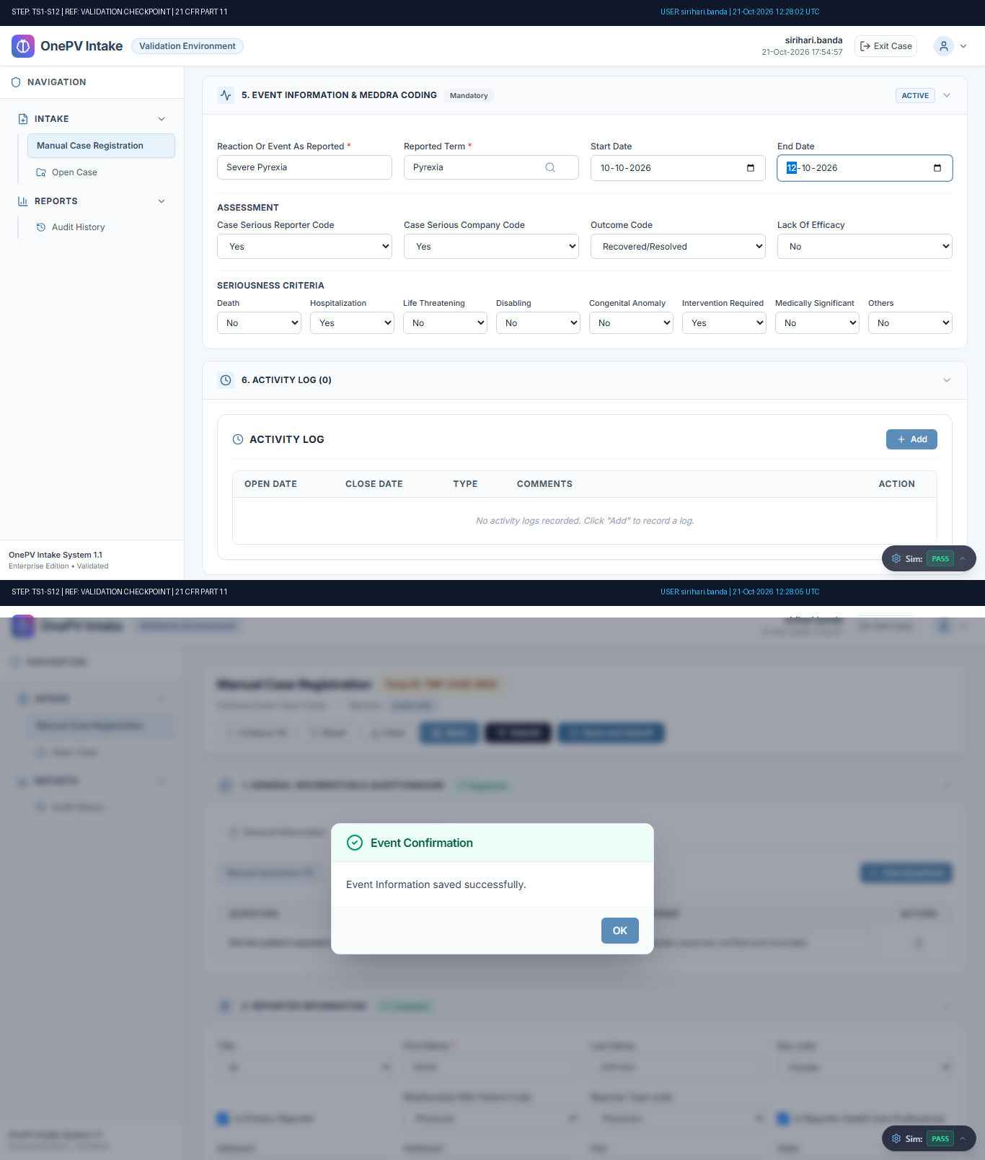
Figure: Audit-Stamped Evidence for TS1-S12 (Ref: TMP-CASE-6802)

Step TS1-S13: Verifying Reported Term’s Meddra Code.
Status: Pass | Observed: MedDRA code verified under Event Information tab.
Procedure: Navigate to Event Information tab.
Under Event Information, verify the Reported term meddra coded.
(Refer expected result)
(((µ)))...
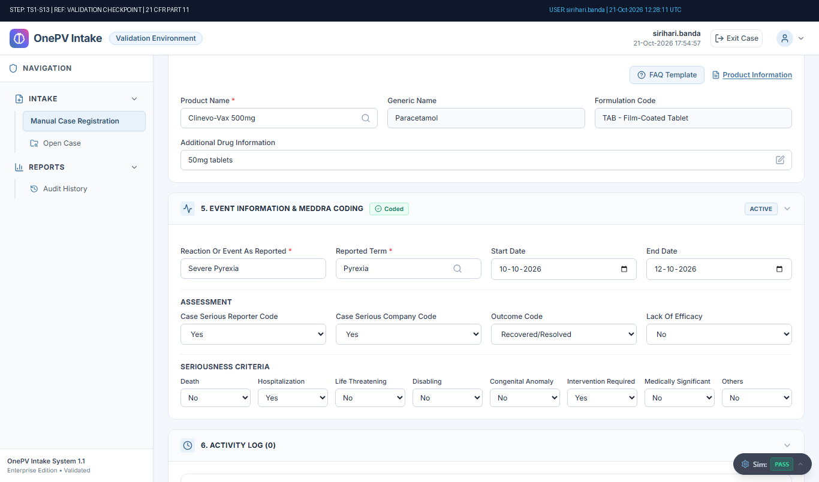
Figure: Audit-Stamped Evidence for TS1-S13 (Ref: TMP-CASE-6802)

Step TS1-S14: System shall allow to add Log details.
Status: Pass | Observed: Activity log added successfully with confirmation.
Procedure: Under activity log, click on Add button.
In the Activity log create page, enter data in below details,
Open Date:
(Select date)
Close Date:
(Select date)
Type:
(Select type from dropdown)
Comments:
(Enter comment)
Click on Save butt...
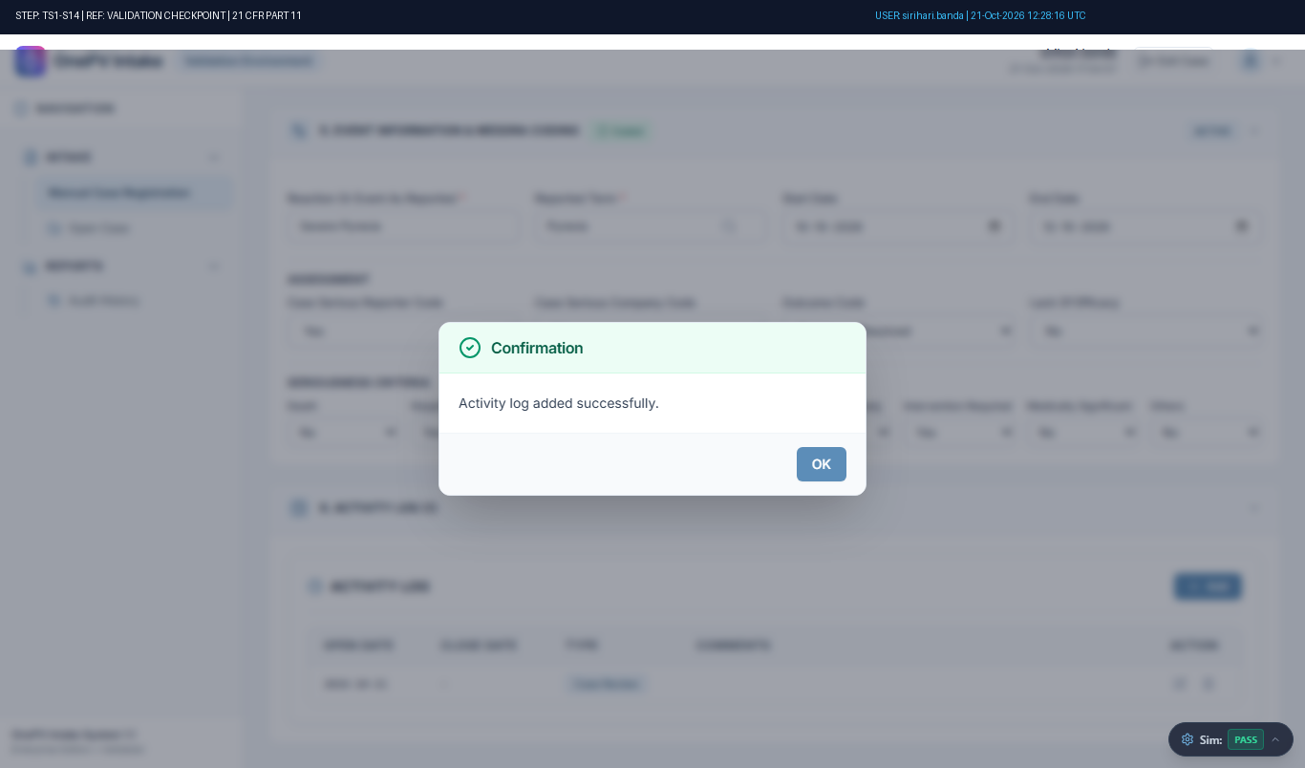
Figure: Audit-Stamped Evidence for TS1-S14 (Ref: TMP-CASE-6802)

Step TS1-S15: System shall allow to Submit case.
Status: Pass | Observed: Case submitted successfully. Official Case Number: CASE-2026-002 generated.
Procedure: Click on Save and Submit button.
(Refer expected result 1)
Click on Yes from the Open Case Confirmation message.
(Refer expected result 2)
(((µ)))...
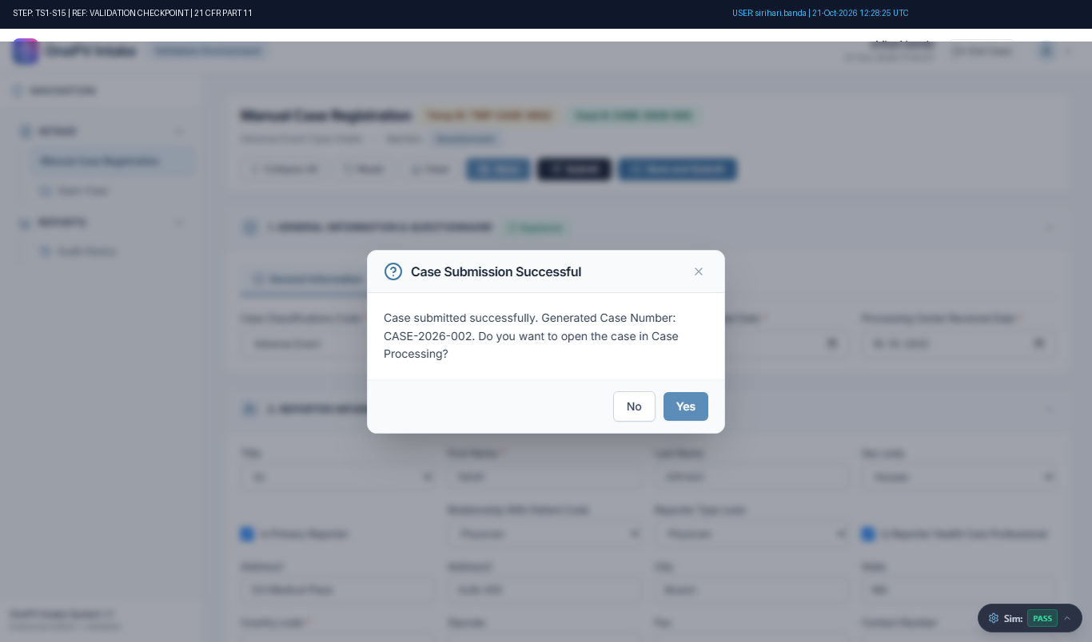
Figure: Audit-Stamped Evidence for TS1-S15 (Ref: TMP-CASE-6802)

Step TS1-S16: Verifying Meddra Code of Event Information in Case Processing page.
Status: Pass | Observed: MedDRA Code data verified in Case Processing page.
Procedure: Navigate to Event Information section, verify the Reported term by mouse hovering on right mark.
(Refer expected result)
(((µ)))...
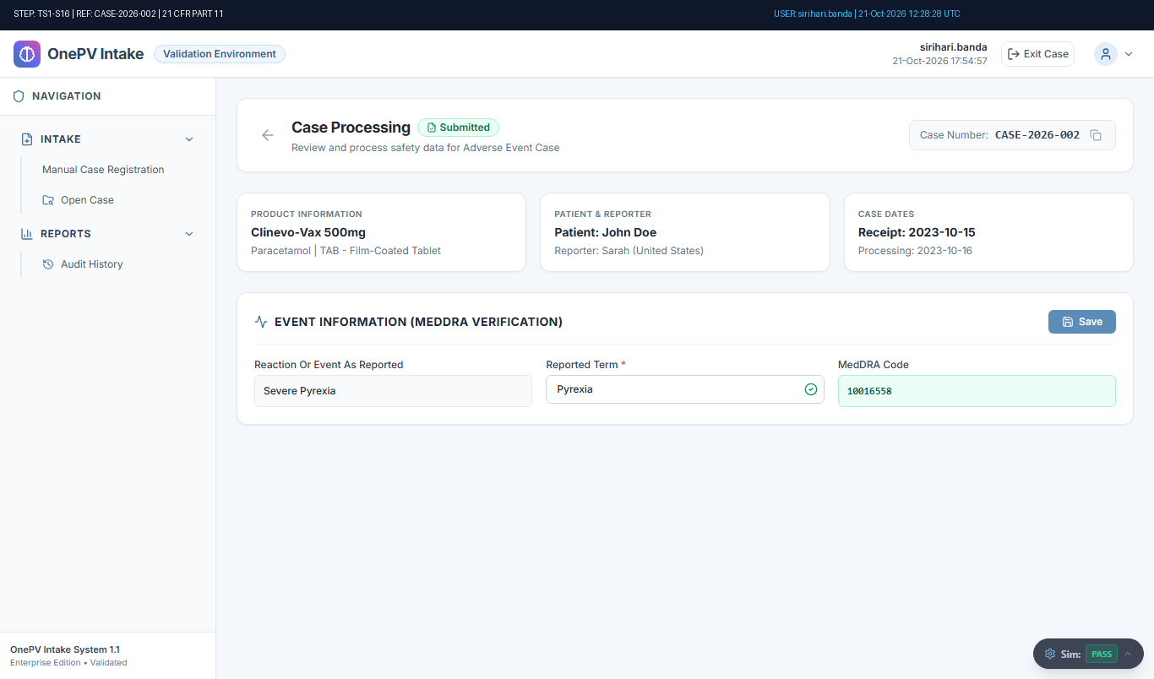
Figure: Audit-Stamped Evidence for TS1-S16 (Ref: TMP-CASE-6802)

Step TS1-S17: System shall allow to Exit from the case processing.
Status: Pass | Observed: User successfully exited from case to Case Intake Search.
Procedure: From the Adverse Event case processing page, click on Exit icon from top menu.
Click on YES from message.
(Refer expected result)
(((µ)))...
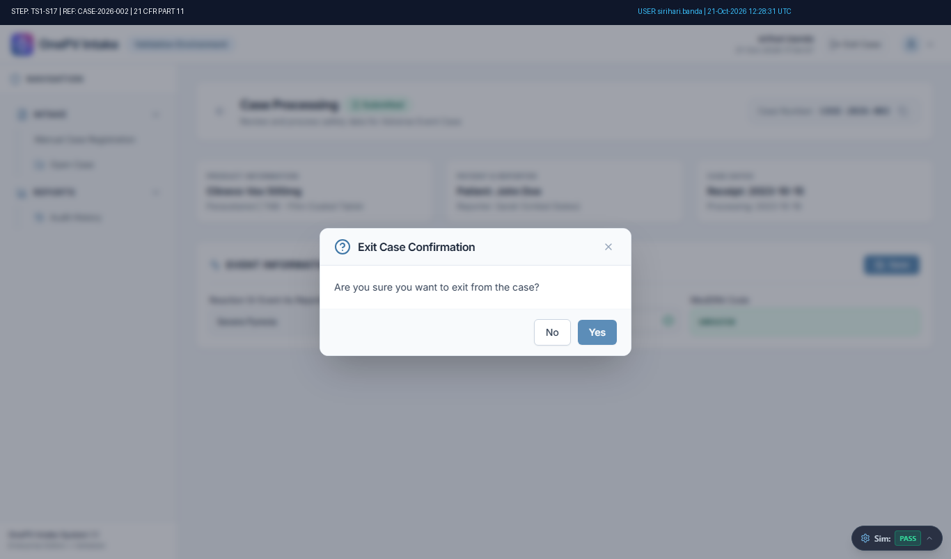
Figure: Audit-Stamped Evidence for TS1-S17 (Ref: TMP-CASE-6802)

Step TS1-S18: System shall allow to Logout.
Status: Pass | Observed: User successfully logged out. Login page displayed.
Procedure: From the Case intake search page, click on the user profile icon.
Click on the Logout button.
Click on Yes from the confirmation message.
(Refer expected result)
(((µ)))...
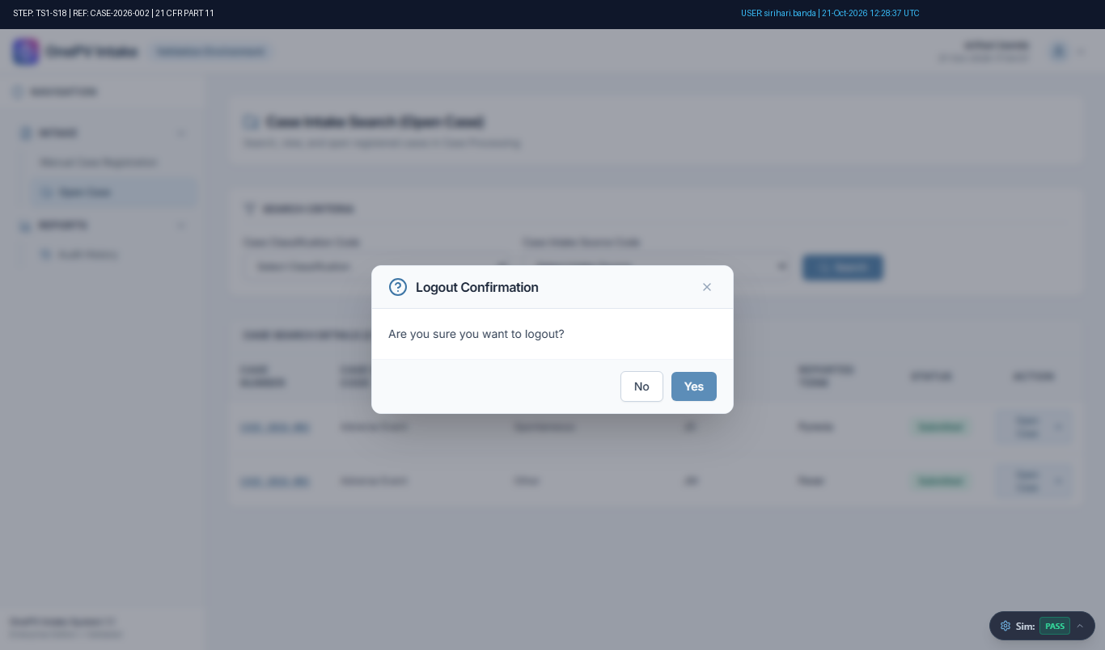
Figure: Audit-Stamped Evidence for TS1-S18 (Ref: TMP-CASE-6802)

